State of the Art Fault Detection and Diagnosis in Power Transformers A Review of Machine Learning and Hybrid Methods

Abstract
Fault detection and diagnosis (FDD) in power transformers is essential for maintaining reliability and safety in modern power systems. Recent trends in transformer fault diagnosis include the use of advanced monitoring systems and data analysis techniques, and implementing effective FDD strategies can prevent costly repairs, minimize downtime, and enhance the overall reliability of power systems. In this work, a systematic review of FDD in power transformers, focusing on machine learning and hybrid methods applications is presented. The methodology comprised a detailed systematic process undertaken to gather, filter, and analyze relevant research papers using Scopus database, while VOSviewer, and biblio metrix tools were utilized for results analysis. The research findings indicate that there is clear progress in detecting transformer faults, moving from older methods like Dissolved Gas Analysis (DGA) to machine learning models such as Random Forest and Convolutional Neural Networks (CNN). Hybrid models combining machine learning with optimization have made detaction more accurate. New tools, including optical sensors, now allow for real-time monitoring. Still, issues like limited data and complex models remain. This study contributes by reviewing how machine learning is applied to transformer fault detection, exploring hybrid methods that combine traditional techniques like DGA with advanced models for better accuracy. It identifies key research patterns, trends, and themes, while also highlighting gaps and offering suggestions for future research to improve diagnostics and monitoring.

Existing System and Disadvantages
Existing systems primarily depend on conventional methods like Dissolved Gas Analysis (DGA) and basic monitoring systems for transformer fault detection. While these techniques are well established, they often struggle with limited diagnostic accuracy, delayed fault identification, and the inability to handle large volumes of real-time data, which can lead to unexpected failures and costly downtime.
- Reactive and Manual: Many existing FDD methods are reactive, addressing faults only after they have already occurred, which can lead to significant damage and downtime.
- Reliance on Thresholds: Simple threshold-based monitoring systems often fail to detect subtle, incipient faults that develop over time.
- Labor-Intensive: Manual inspection and scheduled maintenance are expensive, time-consuming, and can be prone to human error.

Proposed System and Advantages
The proposed system integrates machine learning models such as Random Forest and CNN with traditional diagnostic methods like DGA, creating hybrid FDD solutions for power transformers. By combining data-driven algorithms with optimization techniques and incorporating real-time monitoring tools like optical sensors, this system aims to significantly improve fault detection accuracy, enable faster diagnosis, and enhance the overall reliability of power systems.
- Proactive Maintenance: The system uses predictive models to identify potential faults before they escalate, enabling proactive maintenance and reducing the risk of catastrophic failure.
- Enhanced Accuracy: Machine learning and hybrid models can analyze complex, multi-variate sensor data and identify patterns that traditional methods miss, leading to higher diagnostic accuracy.
- Real-time Monitoring: The system will continuously monitor transformer health in real-time, providing immediate alerts and diagnostics.
- Cost Savings: By preventing failures and optimizing maintenance schedules, the system will lead to significant cost savings for power grid operators.

System Architecture

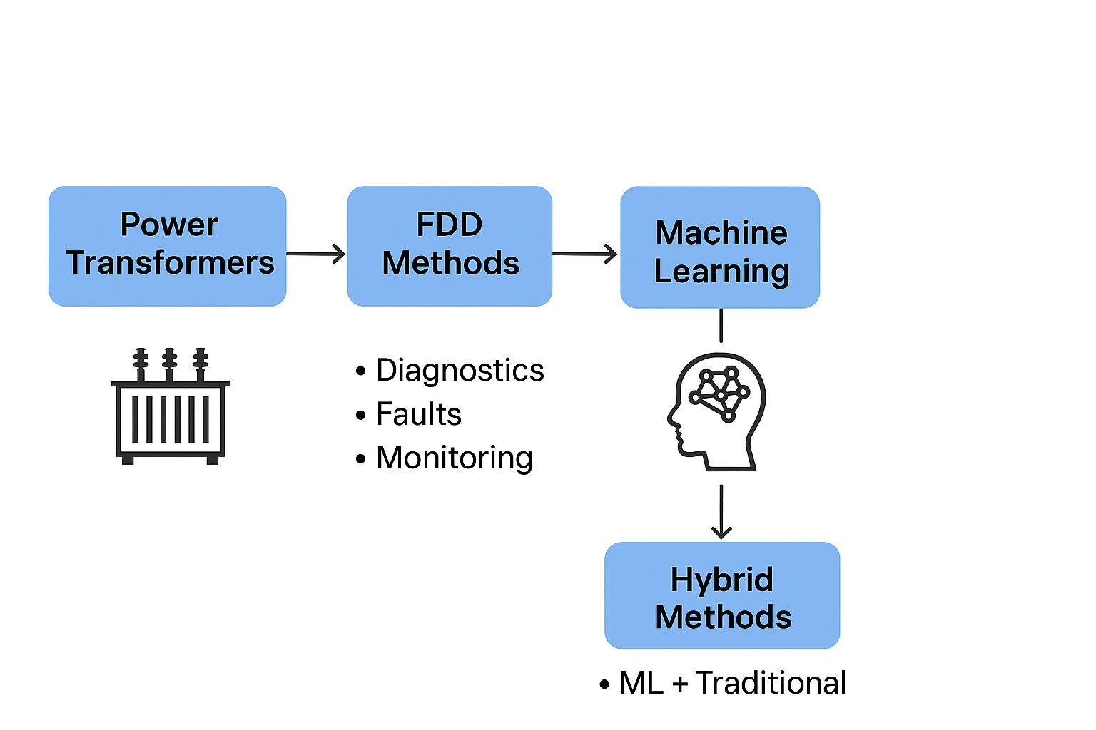Module Description
- Data Ingestion Module: Manages the connection to IoT sensors and data streams.
- Data Transformation Module: Cleans and prepares the data for the models.
- FDD Model Suite: Contains the library of machine learning and hybrid models for fault detection and diagnosis.
- Predictive Analytics Module: Analyzes time-series data to predict future fault probabilities.
- Dashboard and Notification Module: Provides a user interface and manages alerts

Hardware and Software Requirements
Hardware Requirements:
- Sensors: Appropriate IoT sensors for monitoring transformer parameters.
- Server: A high-performance server with a powerful CPU and sufficient RAM for real-time data processing.
Software Requirements:
- Operating System: Linux is recommended for server environments.
- Programming Language: Python.
- Libraries and Frameworks:
  - Data Science: Pandas and NumPy.
  - Machine Learning: Scikit-learn, TensorFlow, or PyTorch.
  - Data Streaming: Kafka or other stream processing frameworks.

Functional Requirements
User Module
- User Authentication & Access
The system should allow users to securely log in and access transformer monitoring data based on their roles, ensuring only authorized personnel can view system information.
- Real-Time Monitoring Dashboard
Users should be able to view real-time transformer health data (temperature, gas levels, sensor readings) through an interactive dashboard.
- Fault Detection & Diagnosis View
The system should display detected faults and their types using ML/hybrid models (e.g., DGA + Random Forest/CNN), helping users understand the transformer condition.
- Predictive Maintenance Insights
Users should be able to view predictions of potential future faults and risk levels based on time-series analysis, enabling proactive maintenance planning.
- Alerts & Notifications
The system should notify users via dashboard when abnormal conditions or faults are detected.
- Report Generation & Export
Users should be able to generate and download reports on transformer performance, detected faults, and maintenance recommendations.
Admin Module
- Admin Authentication & Control
The system should allow administrators to securely log in with advanced privileges to manage the entire system.
- Sensor & Data Source Management
Admins should be able to configure and manage IoT sensors, optical sensors, and data streams connected to transformers.
- Data Processing & Transformation Control
The system should allow admins to manage data cleaning, preprocessing, and transformation pipelines for accurate model input.
- Model Management (FDD Models)
Admins should be able to train, update, and deploy machine learning and hybrid models (Random Forest, CNN, DGA-based methods).
- System Monitoring & Performance Evaluation
The system should allow admins to monitor model performance (accuracy, prediction quality) and system health.
- Alert Configuration & Maintenance Scheduling
Admins should configure alert thresholds, manage notification systems, and schedule predictive maintenance tasks based on model outputs.

